Project Spiral

ABOUT: Participants can draw, paint, sing, act, write a poem or story etc. as they complete each Project Spiral Step.

Project Spiral – Step 1
Who are you right now?

Ask Yourself

- What do I do day to day?

- What am I good at?

- What do I love to do?

- Where do I live?

- How do I get around?

- What is happening around me, down the road, in my neighbourhood, in my country?

- What do I care about?

Project Spiral – Step 2
Where do you want to be?

Part i)

- Set your time frame (is it 6 months, 12 months, even 5 years from now?)

- Think and reflect for a moment about your future in terms of best-case scenario. You may want to consider your future in terms of the project or idea you have in mind.

- Draw a medium-sized circle in the centre of the page, so there is still plenty of space around it.

Ask Yourself

- What do I see in my future? (what do you want to see in your future?)

- What am I doing with my time?

- What skills do I have?

Part ii)

- On the same piece of paper, draw a larger circle around the circle you have already drawn and filled in with words, symbols or pictures.

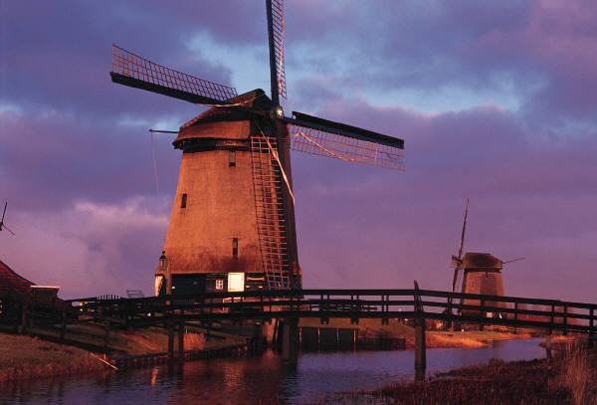
- In the space, draw or write what your community looks like in the future. Your community may be in the same village, or you may be connected by the Internet.

Ask Yourself

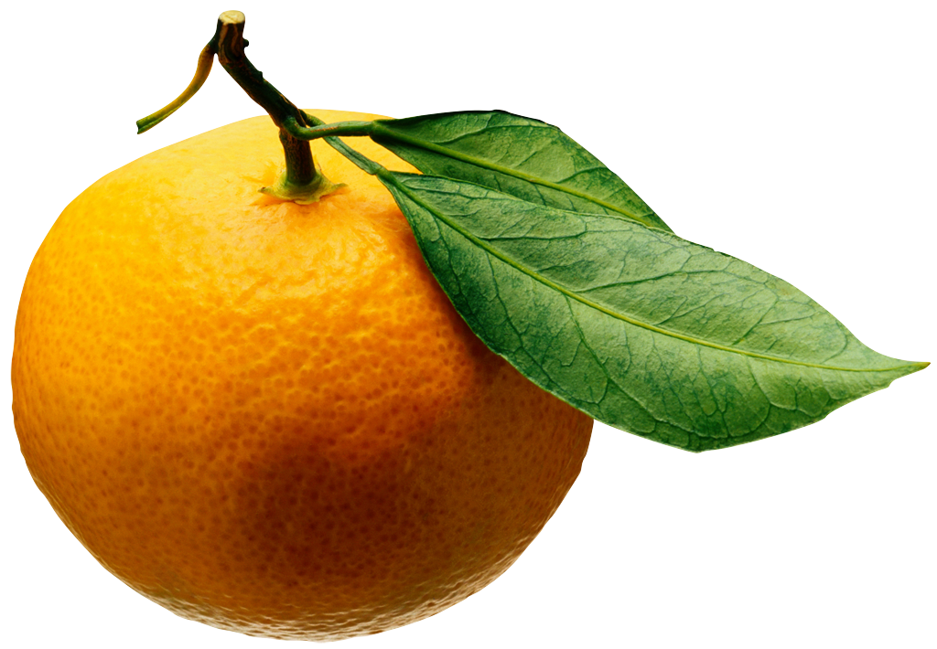
- What do I see for my community?

- How am I a part of it?

- What’s happening in nearby areas?

- What services are available to people?

- Where do people get together?

Project Spiral – Step 3
What are your values?

Your Values represent your own personal guide to live by.
By working through Step 1 and Step 2 you have a clear and detailed picture of where you are right now, where you want to be and where you want your community to be.

By taking some time to reflect on your life and your community, you may have been reminded of qualities that are important to you- your values.

Your values contribute to the quality of your life and the people around you. You may have values that you didn’t think you had. By now, you have probably heard a lot about other people’s values – the values held by your parents, your friends and your culture.

Now It’s time to look at your personal values.
Imagine that you have lived to be 100 years old. You have thrown a big party for yourself and all of your friends and family. They are standing up and giving speeches about the life you have lived and the work you have done.

- What are they saying about you?
- What are the ways that you have made a difference in the world?
- What are the qualities that you are best known for?

From this, write a list of your personal values. Begin with “I value…”

For example;
- I value doing what I say I will do.
- I value telling it like it is.
- I value honest relationships.

Another way to think about your values is to ask yourself:
How can I be true to myself?

Project Spiral – Step 4
What is your idea?

What is it that YOU want to DO? What idea do you want to develop?

You need a Project/ Social Business summary.

By answering the following questions, you will come up with a first take. You don’t have to sweat over every word. This is a rough outline. There will be other opportunities to get it right.

- What is the idea?

- Who’s it for or whom do you want to reach?

- What will happen?

- What change do you want to see?

- What resources or help do you need?

- When will it happen and for how long?

Congratulations. You now have a Project/ Social Business summary!
Project Spiral – Step 5
Who can help?

Think of the people around you as a walking-talking resource that you can draw on to make your projects happen.

Let’s revisit who your community is. Get a blank page and get some actual names on the page.

Start by talking to your friends and family (your core community) Then talk to people you are less familiar with (your Informal and Formal Community). When you are asking for people’s advice whom are not your friends or family, you need to be very clear about the project and why you want to do it. You may have to make an appointment to see them. If you are organised and know what you want, they are more likely to help you.

Think about

- Who do you want to work with?

- Or who do you HAVE to work with?

- Who can share their knowledge?

- Who can share their resources?

- Who can give their time?

- Who can give their money?

Core Community
- Your friends
- Your family
- Community elders

Formal Community
- Government agencies and departments
- Businesses
- Legal framework
- Cultural framework
Project Spiral – Step 6
Who has done it before?

- Find out who the people are with knowledge in your community such as community leaders and elders. From asking around your communities, work out who the people are with the most relevant knowledge.

Online Research:
- Type in the key words of your project idea.
- Write a list of similar projects and the people that were involved.
- Are there any gaps in what is already out there?
- Can you tailor your idea to fit the gap?
- Make a list of questions that you would like to ask.

Your aim for doing this is to:
- Begin to identify that there is a need for your project/product in the community and
- Find formal contacts who can share their knowledge and expertise in the field you are working in.

Document your research
Write down what you found out and where you found it. Be prepared to take notes when you talk to people. Their ideas, feedback and comments will help you grow your idea or project.

Internet search items:

Similar projects:

People to talk to:

Resources (for example, books, films, music) to look out for.

Project Spiral – Step 7
Does the idea meet a need?

A strong idea meets the needs of the community
By answering the following questions, you can see how strong your idea is.
Remember that the more your project idea can match a real need in the community, the stronger and more effective it will be.

- What is your project idea?

- How does your project meet a need in the community, the possible ‘market’?

- What are you going to do that will address the need?
- What activities will you return to address the need?
- Who will take part and how often will activities run?
- Who will benefit and how many?

- What are the key goals of the project?
- What are the risks of the project – what might go wrong?

- What will you do to reduce the risks of the project?

Project Spiral – Step 8
Write your project plan?

Knowing the need
What is the need? (Check out what you’ve written for Step 7.)

How will your project create positive social change?

What success looks like
- How will you know if your project has been a success for all the people involved?

- How will you collect the information to prove your success?

The dollars and cents
- How much will your project cost? Make a rough estimate, considering your wages, project materials, venue cost, stationary etc.

- How much money can you raise? Where will it come from? How long will it take you to raise and collect the money?

Resources
- What other resources do you need to make your project a success?

- Where will you get these from?

People who can help
- Who can you work with to make your project a success?

- What jobs can other people do to get your project going?

This Project Plan becomes a useful document that you can send to your informal and formal communities to get their support or apply for funding

Project Spiral – Step 9
What do you want to know?

What is consulting?

It is talking with groups of people (not just your friends) and asking them questions to get their honest feedback. Working with these ideas, you can develop your project so that it reaches its best potential and meets a real need.

Sometimes when you’re excited about an idea, you want to hear that everything is great and you don’t usually want any criticism. You want to hear that your idea is going to work. Consultation is about really checking this out. For consulting to count, you have to listen to people. That means hearing what they tell you even if it isn’t all good.

Why listen?

Getting different points of view will make your project stronger. A strong idea is one that had considered the advice of community leaders and elders and the feedback from a target group, and has taken that on.

Also, if people know that you are open to their ideas, they will be happy to share their knowledge with you. They may even want to help you with the project by giving their time, skills or resources.

- When you consult with your community they are likely to turn up to your events or participate in your project because you have created something that they want.
- You might think your idea will attract a lot of people. It might not. Give people an opportunity to tell you why it might not.
- When you consult with your target group, they feel a part of the project. The people you consult with can spread the word for you – they can tell their friends and networks about your project.
- When you consult you can gain a broad view and get feedback on specific details of your project.

Ask yourself
- How am I feeling about the idea or project right now?
- What is working really well?
- What is challenging to me?
- What could I change to get a better result?
- How am I building on from what I have learnt from other people and what I know myself?

Now imagine you throw an event to get find out more about how you sell your product/service. This “talk fest” is a gathering of people that you have recruited from your target group, who you can consult with about your project idea.

Before you consult with people you need to know the basics of your project such as…

- Target audience
- The geographic location
- The approximate times / Opening hours
- Ideas for a venue
- How many people you want to participate

When you are clear on these details, you need to work out what it is you want to know and how you are going to ask. For example, you might organise an organic food tasting event. You want to know:

- What is your message?
- How will the food-tasting event get the message across?
- Will people turn up?

You may ask people at the event a range of broad or specific questions.

Broad Questions
For example:
- How is organic food a healthier option?
- What pesticides are used in agriculture?
- How can pesticides affect the health of people?

Specific Questions
For example:
- How much money would people be prepared to pay for each fruit/ vegetable?

- Would more people come if you offered fruit smoothies?
- What events would people attend where you could find organic food?

Getting people to your talk-fest
- Word of mouth
- Tell all of your friends
- Print media (pamphlets, newspaper/magazine adverts, classified/ community section of your local newspaper, public notice boards)
- Community announcements on radio
- Schools and Universities
- Community centres
- Email groups

When you are organising your talk-fest, make sure that the group is small enough to be effective. Effective means that everybody has a chance to be heard. Between six and ten people is a good number to aim for.

Project Spiral – Step 10
Who do you want to talk to?

Important elements of a food-fest

Before…
- Organise food and refreshments
- Find a comfortable environment and a place that people are familiar with
- Tell them what they are there for
- Tell them what you are going to do with the information that you collect

During…
- Have group guidelines
- Let people have their say
- All people who turn up get to participate
- Let people know what they are saying will be considered
- Respect people’s time, and don’t let the talk-fest go on forever. Give clear time frames One hour is probably enough time.

After…
- Thank them for coming
- Record the information and keep it safe. Some of the information may be personal and you want to be able to guarantee that you won’t be sharing it with anyone outside of your project.

Let’s break it down
- Write down what you want from the talk-fest
- Get a group together
- Meet with them
- Ask them broad and specific questions
- Keep their answers!
- Use their answers to develop your ideas

A project reaches its best potential when…
…it is valued by other people in your community.
---it is appropriate to their beliefs, interests and ways of doing things.
… it best addresses the community’s needs and wants.

A talk-fest allows you to test your idea with your target group and refine your idea in response to their needs.

Project Spiral – Step 11
How much will it cost?

Knowing what you can afford and adapting your project can save you a lot of headaches. Budgets often get ignored. But facing up to them early could be the difference of you really enjoying delivering your project and it causing you a lot of sleepless nights.

This is a sample budget

Begin by working out how much money you have (your Income) and how much money you are likely to spend (your Expenses).

- The total difference between your Income and your Expenses is the amount you need to find through Other funding.
- Always estimate you will spend more, rather than less
- Remember there is always In-kind support. This is the stuff you get for free.
- If your expenses are still more than your income you may have to do some research to find Other funding.

INCOME – is money or resources coming into your project.

Other funding – is where you can get more money for your project. Is there funding you can apply for? You may need to do some research online or ask around your networks.

Volunteer time – Work out an hourly rate for your volunteer time, such as 150 pesos per hour. This is not the amount you pay them. It is just a way to calculate how much they are worth by multiplying that rate by the hours that they have agreed to work.

EXPENSES – This is money you have to spend for your project.
Wages – Don’t forget to pay yourself and other people too. Not everyone can afford to volunteer their time.

INCOME | In-Kind | Cash
Personal Saving
Other funding
Volunteer time
Sub-total
Total
EXPENSES
Wages
Project Materials
Food for volunteers
Printing
Postage
Transport
Phone
Venue/ Office
Stationary
Internet
Miscellaneous
Sub-total
Total

Project Spiral – Step 12
Write your Action Plan

This is the last step of Phase One. You should be feeling pretty pleased with yourself. You have given your idea a great chance of being successful by imagining, reflecting, researching and consulting. Before you head off to make change in your world, let’s make sure your idea is feasible.

Feasible means that your idea…
Meets a defined need

Builds on what has worked before

Listen to the people involved in your project and in particular the people who are going to benefit from your project.

Starts small and builds up to a grand idea

Works with a realistic budget and timetable

Works with a range of people with different skills and experience

Can you tick all of the boxes?
If you honestly can, then it’s time for you to begin working on your action plan. If you are able to tick a few boxes, but not all of them, you can skip back to step 7 and revise your Project Plan. Then just continue step by step until you are back here, at Step 12. Spend more time imagining, reflecting, researching and consulting.

The 12 steps of this guide are yours to play with. Revisit the guide whenever you have the feeling that something needs to change.

Remember

- Be true to your values
- You don’t have to go it alone
- Connect with your community
- Find supporters

Action Plan
This is it! Your strategy to making your project happen.

What needs to be done?
When does it need to begin?
When does it need to be done by?
Who can help?
What resources do I need?

